Launch a life changing legacy
During these unprecedented times, we have come to recognise how vital the simplest things can be.

From realising the human impact of a caring, supportive hug, to the critical washing of hands to keep us safe.

Water – the giver of life. How amazing would it be to facilitate that for an entire community?
A unique opportunity exists right now, to make a direct and positive difference to a community of amazingly resilient and wonderful people. Vibrant, hardworking families who, despite hardships encountered, due to difficult terrain, contaminated streams - even earthquake devastation, strive to exist the best way they can.

Danda Tole needs water.
Situated within the majestic, dramatic landscape of Nepal, the village is home currently, to 226 people – all of whom need access to a clean water supply to transform their lives. Instantly reducing water borne diseases, improving personal hygiene and enabling crops and produce to be grown closer to home, thus reclaiming back for productive use, the three hours taken each day, by each family, to fetch and carry water.

This goes far beyond any crucial financial investment required to achieve the practical objectives.
Involvement in this project creates the possibility to influence lives and the very future of Danda Tole itself. To visit the village, stay in the homestay, experience the magnificence of the Himalayas – trekking with local guides from the village, building relationships that make a real and tangible difference.

By helping people to change their lives – might just change yours.
We’ve already made a start! Our valiant fundraising to date has already had an impact within the village.
- 16 homes rebuilt – cost efficient solar panels replaced dangerous kerosene and candle lighting
- Initiated self - sustaining health & hygiene programme – women trained to make reusable sanitary products and educate village community regarding sanitary health, pregnancy and personal hygiene
- Assisted provision of school toilet facilities – enabling girls to attend regularly, avoiding monthly absences
- Promotion of vital local business – village leader Binay Lama expert trekking guide - www.sacredhimalaya.com

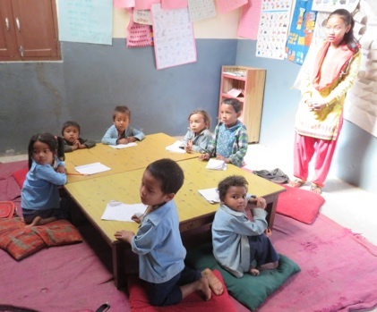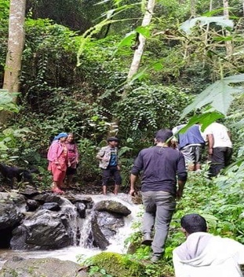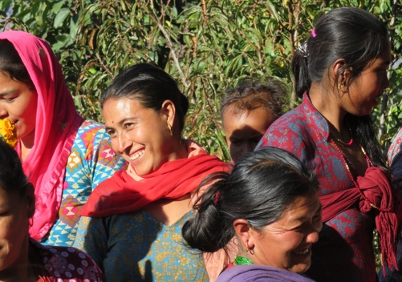
You are invited to read the attached proposal for more details about this life changing legacy.
With the total project costing £33,000, this equates approximately to just £146 per person, reflecting the current population of Danda Tole. We hope you will be encouraged to explore this vision further and consider how you might like to become involved with this incredible, humbling and absolutely achievable project.
I would welcome any future conversation. Please do get in touch.
With a hopeful heart,

Phillipa Wilson
E: paw750@btinternet.com T: 07967754004 W: www.oakwoodyoga.co.uk

