Moola Bandha – perineum contraction
(moo-lah bahn-dah) moola = root (of any tree, but also figuratively the lowest part of anything), firmly fixed, source, cause
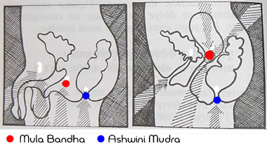
Step by Step
Stage 1 Sit comfortably. Relax whole body, close eyes, and steady the breath.
Bring the awareness to the perineal/vaginal area. Focus on that area for a minute or so.
Contract this region by pulling up on the muscles of the pelvic floor and then release them.
Continue to briefly contract and relax the perineal and vaginal region as rhythmically and evenly as possible.
Stage 2 is to slowly contract and hold the contraction. Breathe normally; do not hold the breath.
Be totally aware of the physical sensation.
Contract a little higher...whilst keeping the body relaxed and tension free.
Contract only those muscles of moola bandha. At first the anal and urinary sphincters will contract, but with practice and greater awareness, control will develop.
Repeat up to ten times with maximum contraction and the body totally tension free.
Advanced
You can combine moola bandha and jalandhara bandha - but only if holding the breath is not contraindicated for you.
Inhale deelply, retain the breath inside and perform jalandhara bandha, and then perform moola bandha by slowly contracting the perineal or vaginal muscles and contracting as tightly as possible – but without strain.
When you are ready to exhale; slowly release moola bandha, raise the head to the upright position and exhale. Practice up to ten times.

Benefits
- Stimulates pelvic nerves and tones the uro-genital and excretory systems.
- Intestinal peristalsis is stimulated, relieving constipation and piles.
- Releases energy so effective through whole body via the brain and endocrine system
- Helps asthma, bronchitis and arthritis
- Effective in releasing brahma granthi and for locating and awakening mooladhara chakra.

Contraindications and Cautions
- Approach the practice of all bandhas and body mudras cautiously, especially without the direct guidance of an experienced teacher
- Can increase hyperactivity
- Do not practice advanced practice if pregnant....no breath retention.

To practice try the following:

All fours, table position...place a block between the thighs and contract the perineal or vaginal muscles.
In Marjariasana....use a block between the thighs and watch and move into happy and grumpy cat.
In Parvatasana (mountain, down dog) ...again place a block between the thighs.
In Tadasana – block between the thighs
In Uttanasana (standing forward fold) -again place a block between the thighs.

All of the above help the pelvic floor muscles but work with moola bandha. These postures also bring awareness to mooladhara chakra.

References:
Asana Pranayama Mudra Bandha ~ Swami Satyananda
Image from www.theyogimovement.com

