Jalandhara Bandha – throat lock
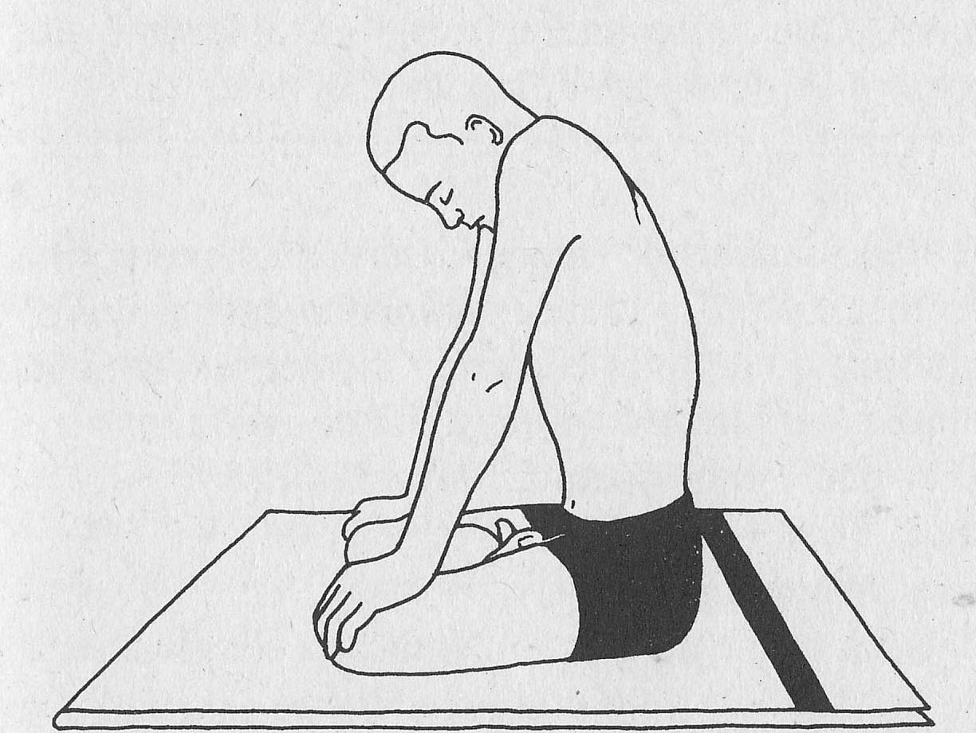
(jah-lahn-DHA-rah bahn-dah)
jalan = net
dhara = stream or flow
Step by Step
Sit in a comfortable pose, spine straight, knees in contact with the floor or supported by blankets. You could stand if need be to practice.
Palms on the knees. Eyes closed, release the whole body.
Inhale slowly and deeply, and retain the breath inside; release the chin toward the chest but draw it back slightly. Straighten the arms and lock them, pressing the hands down onto the knees.
Simultaneously hunch the shoulders upward and forward.
Stay in this position for as long as possible without strain. When you are ready to release; relax the shoulders, bend the arms, release the throat lock by raising the head and exhale.
Repeat when respiration has returned to normal. Repeat up to 5 times.

Benefits
- Mental relaxation, relief of stress, anxiety and anger
- Develops meditative awareness or one-pointedness
- Stimulus on the throat helps balance thyroid function and regulates the metabolism
- Protects the brain, eyes, and inner ears from the internal pressure of the retained breath

Contraindications and Cautions
- Avoid this bandha if you have a neck injury or cervical spondylosis
- Vertigo
- High blood pressure or heart disease

Tips
When you are used to doing this practice; try holding when the exhalation is held out.
You could introduce a count as well.
Whilst practicing you can have the awareness at the throat pit; or vishuddhi chakra.
Do not inhale or exhale until the head is fully central; and the chin and arm locks have been released.
This bandha is often done in conjunction with Moola Bandha and Uddiyana Bandha

References:
Asana, Pranayama, Mudra and Bandha ~ Swami Satyananda
Image from same book.

