Ingredients
- 300g rice noodles
- 3 large handfuls frozen peas
Sauce ingredients
- 1 small butternut squash (between 800g & 1kg)
- ½ inch cubed fresh ginger
- Big pinch sea salt
- Big twist of black pepper
- 150ml coconut cream ( ⅔ cup)
- 125ml water saved from water in cooking process ( ½ cup)
- 2 teaspoons ground coriander (optional)
Instructions
- Put water in a pan and turn on the heat, placing on the lid.
- Peel and cube the squash into small pieces and then pop straight into the pan to cook (make sure there is enough water to just cover the squash). (If you have time I prefer to roast my squash)
- Get the ginger ready by peeling and chopping into small pieces (or grate with a fine grater).
- In the meantime get another pan for the rice noodles. Put plenty of water in and bring it to the boil. Once it is boiling, pop the noodles in and turn it down to simmer. Rice noodles normally take about 5 minutes to cook, but check the instructions on your packet.
- After the noodles have been cooking for a couple of minutes, pop in the frozen peas (if this stops the boiling process just turn the heat right back up again). Once the noodles have cooked, strain with a strainer.
- When the squash is cooked (if the chunks are small, this should be done in less than 10 minutes), strain off the water - but save about 125ml ( ½ a cup) and add it back in right away. (I normally just guess this part to be honest and strain most of the water off and then leaving about 125ml in, because when I am in a hurry I don't really measure anything).
- Toss in the ginger, salt, pepper, coconut cream and mix for another minute - then blend until creamy. I find blending from a pan like this easiest with a hand blender (saves on washing up) although a jug blender will work well too.
- Mix the sauce with the noodles & peas and serve immediately.
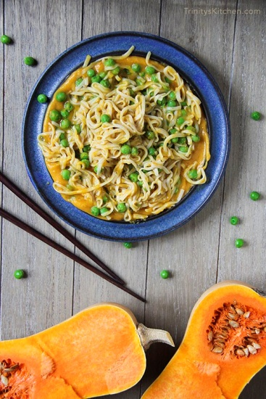
Source: http://www.trinityskitchen.com/

