Varicose Veins
Veins run all throughout the body and their job is to return blood to the heart and lungs to receive crucial oxygen supplies, before being sent back around the body via arteries. Blood travelling back up the veins in your legs not only has the furthest distance to travel, but the blood must also be shunted along against the pull of gravity. Small vales are in place to help prevent the blood flowing backwards.
‘Varicose veins’ means that there are damaged valves. As a result, blood struggles to pump upwards, and instead, it starts to pool within the veins, causing swelling.
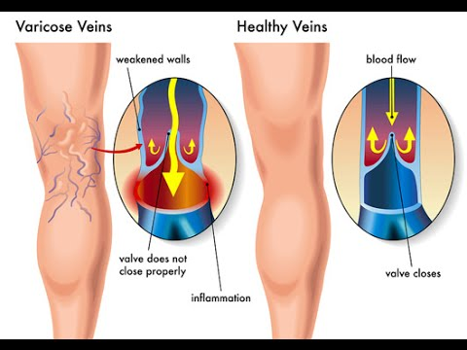
Source: https://www.youtube.com/watch?v=r-nvlh1XV9w
Yoga postures that may help:
- Legs up the wall...Viparita Karani
- Standing forward fold – Uttanasana
- Reverse posture or Mountain – Tadasana
- Shoulder stand – Sarvangasana
- Wind relieving pose – apasana or pawanmuktanasana
Foods that may also help:
- Berries – deep coloured berries like blueberries, blackberries or blackcurrants
- Avocado
- Buckwheat
- Fibre
- Citrus fruits
Supplements that may also help:
- Horse chestnut
- Gotu kola
- Butchers broom
What to avoid doing:
- Standing or sitting for long periods...move around every 30mins
- Avoid sitting crossed legged
- Eating too much as being overweight can aggravate the condition
- Growing older!!!!

