OM MANI PADME HUM
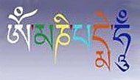
Om  (ohm) | Ma  (mah) | Ni  (nee) | Pad  (pahd) | Me  (may) | Hum  (hum)
Jewel in the heart of the lotus.

Keep repeating and repeating it. This is the mantra that fills Tibetan prayer wheels. You can sit to repeat or repeat whilst carrying out any work. Feel it.

